# **OpenH264 Encoder Conformance Test**

Table of Contents

OpenH264 Encoder Conformance Test 1

1. Conformance Test brief introduction 3

1.1 Conformance test for one case 3

1.2 Conformance for one YUV 4

1.3 Conformance test for all YUVs 5

1.4 Test data structure 5

1.5 SGE test 6

1.6 Jenkins based test set test mode 7

2. Conformance Test script basic info 8

2.1 Brief introduction 8

**Repos info** 8

**Support platform** 8

2.2 How to use 9

**2.2.1 Linux single machine local test** 9

2.3 Codec and test tools 15

**2.3.1 Codec for test** 15

**2.3.2 App tools for test** 16

2.4 Test cases 17

**2.4.1 Test case configuration files** 17

**2.4.2 Test case generation** 18

2.5 Test data 19

**2.5.1** **Test data for one case during test** 19

**2.5.2** **Test data for one test cases set** 20

**2.5.3 How to reproduce failed case** 22

**2.5.4 Test data for all YUVs** 23

2.6 Test report 25

2.7 Basic flow chart for test preparation 27

2.7.1 basic flow chart 27

2.7.2 Example 27

2.8 Basic flow chart for testing all cases 30

**2.8.1 Test all cases for all YUVs** 30

**2.8.2 Test assigned cases within one test cases set for one YUV** 31

**2.8.3 Test one case** 32

2.9 Basic flow chart for check final test result 33

3 Jenkins based conformance test 34

3.1 Basic test architecture 34

3.2 Test set and Jenkins slaves task assignment 35

3.3 Jenkins jobs 36

3.4 Test data and test report 36

3.5 Failed cases reproduce and analysis 36

**Please refer to 2.5.3 How to reproduce failed case** 36

4. SGE based conformance test 37

4.1 Basic test architecture 37

4.2 Test set and Jenkins slaves task assignment 38

4.2.1 Basic module 38

**4.2.2 Basic SGE Test flowchart** 39

4.3 Pre-Module of SGE Test 40

4.5 Post-Module of SGE Test 42

4.6 Jenkins jobs for SGE test 42

**4.6.1 Period SGE submit** 43

**4.6.2** **SGE test status detection jobs** 43

4.3 Test data and test report 44

4.4 Failed cases reproduce and analysis 44

5. SHA1 tables generation 45

6. SGE install and configuration 46

# **1. Conformance Test brief introduction**

## **1.1 Conformance test for one case**

**

## **1.2 Conformance for one YUV**



## **1.3 Conformance test for all YUVs**



## **1.4 Test data structure**



## **1.5 SGE test**



## **1.6 Jenkins based test set test mode**



# **2. Conformance Test script basic info**

## **2.1 Brief introduction**

### **Repos info**

* GitHub URL： <https://github.com/shihuade/Conformance-Test-Openh264.git>
* Branch: master
* Basic introduction

**Support test mode**

* Mac/Linux local test mode for both SCC and SVC
* Linux Jenkins based test set mode for both SCC and SVC
* Linux SGE test mode for both SVC and SCC
* Mac/Linux SHA1 tables generation test mode for both SCC and SVC

### **Support platform**

* Linux:
* Mac OS/Unix

For more detail, please refer related chapters in this document

## **2.2 How to use**

### **2.2.1 Linux single machine local test**

* Step 1:

Change **Testplatform** to **Linux**,in one cfg file under CaseConfigure/*.cfg which you want to test

#============================== Test platform =======================

TestPlatform:  Linux            #test platform, Mac or Linux

#============================== Test platform =======================

* Step 2:

For SVC, run below command like

./run_Main.sh LocalTest ./CaseConfigure/case_SVC.cfg

For SCC, run below command like

./run_Main.sh LocalTest ./CaseConfigure/case_SCC.cfg

* Step 3:

Wait final test result and test result will be under

SHA1Table/*

FinalResult/*

FinalTestReport/*

**2.2.2 Linux Jenkins based test**

**Jenkins based test, will assign test cases to Jenkins slaves.**

**Jenkins job, please refer to:**

[**http://10.140.198.27:8080/view/ConformanceTest/job/OpenH264-Encoder-Conformance-Test/**](http://10.140.198.27:8080/view/ConformanceTest/job/OpenH264-Encoder-Conformance-Test/)

**For example,**

**in CaseConfigure/, there are 20 cfg files for SVC and SCC test case**

case_Jenkins_SCC_TestSet0.cfg

case_Jenkins_SCC_TestSet1.cfg

case_Jenkins_SCC_TestSet2.cfg

case_Jenkins_SCC_TestSet3.cfg

case_Jenkins_SCC_TestSet4.cfg

case_Jenkins_SCC_TestSet5.cfg

case_Jenkins_SCC_TestSet6.cfg

case_Jenkins_SCC_TestSet7.cfg

case_Jenkins_SCC_TestSet8.cfg

case_Jenkins_SCC_TestSet9.cfg

case_Jenkins_SVC_TestSet0.cfg

case_Jenkins_SVC_TestSet1.cfg

case_Jenkins_SVC_TestSet2.cfg

case_Jenkins_SVC_TestSet3.cfg

case_Jenkins_SVC_TestSet4.cfg

case_Jenkins_SVC_TestSet5.cfg

case_Jenkins_SVC_TestSet6.cfg

case_Jenkins_SVC_TestSet7.cfg

case_Jenkins_SVC_TestSet8.cfg

case_Jenkins_SVC_TestSet9.cfg

**For more detail about test set, please refer to:**

AboutJenkinsTestSet.txt

**For each Jenkins slaves, run below command, take SCC test set 0 for example:**

**./run_Main.sh LocalTest case_Jenkins_SCC_TestSet0.cfg**

**note: please make sure that there in test YUV desktop_dialog_1920x1080_i420.yuv**

**under /home/Video/YUV on test slave or you can change the YUV location**

**For Jenkins job run for one test set, take SCC test set 0 for example,**

**you can refer to below Jenkins job URL for more detail.**

[**http://10.140.198.27:8080/job/OpenH264_ConformanceTest_SCC_TestSet0/configure**](http://10.140.198.27:8080/job/OpenH264_ConformanceTest_SCC_TestSet0/configure)

**To Optimize overall test runtime for all test cases,**

* **Test set cfg file will need to optimize based on actual historical run time in future.**
* **And the script level optimization is also need to decrease run time for one test cases**

**2.2.3 Linux SGE based test**

**SGE test is based on SGE distribution system and assign test tasks to SGE slaves.**

**For more detail about SGE test, please refer to**

* Chapter SGE based conformance test
* Chapter SGE install and configuration

SGE based test will be transform to 2.2.2 test mode,

and will be removed in future

**For SGE test on SGE master:**

**Run below command:**

* SCC: ./run_Main.sh  SGETest    ./CaseConfigure/case_SCC.cfg
* SVC: ./run_Main.sh  SGETest    ./CaseConfigure/case_SVC.cfg

**For SGE test on SGE master based on Jenkins:**

**Please refer to Jenkins job(will be removed)**

**1）Openh264-SGE-Job-Submit**

[**http://10.140.198.27:8080/view/SGE-Test/job/Openh264-SGE-Job-Submit/configure**](http://10.140.198.27:8080/view/SGE-Test/job/Openh264-SGE-Job-Submit/configure)

**after running this job, SGE test tasks will be assigned to SGE slaves**

**job artifacts will give more detail about SGE jobs submit, as show below:**

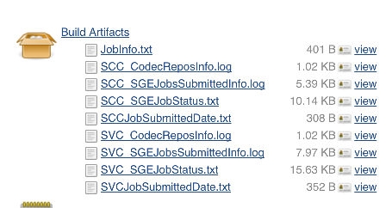

**And need to wait for final test result, sometimes may need 6~12 hours to compete all test cases on SGE which run in background**

**If you want to check the test status and result, please go to 2).**

**2）penh264-SGE-Job-status-And-TestResult**

<http://10.140.198.27:8080/view/SGE-Test/job/Openh264-SGE-Job-status-And-TestResult/configure>

**if there are failed cases, this job status will be marked as failed, and the artifacts files will give more detail about which YUV in which case on which SGE slaves failed**

**for more detail about test status and result please refer to artifacts as show below:**

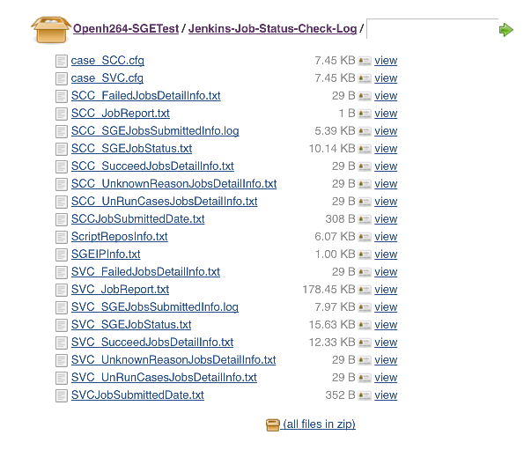

**take SVC_JobReport.txt for example:**

**below shows that test YUV candyHF2_640x480.yuv with 1000 test cases which running on ZhangFei SGE Slaves**

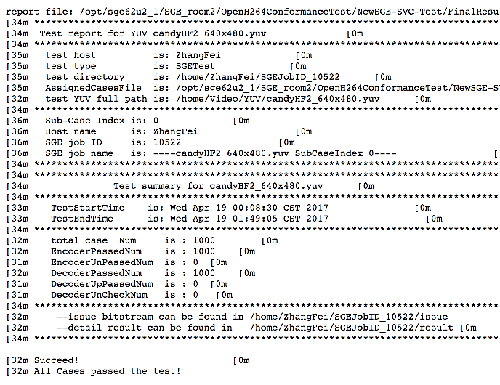

**2.2.4 Mac/Unix single machine local test**

**note:**

**#\*\*\*\*\*\*\*\*\*\*\*\*\*\*\*\*\*\*\*\*\*\*\*\*\*\*\*\*\*\*\*\*\*\*\*\*\*\*\*\*\*\*\*\*\*\*\*\*\*\*\*\*\*\*\*\*\*\*\*\*\*\*\*\***

For downsample and extractor app tools,

which using for multiple layer cases,

currently, there are no mac version,

so, on mac, only support AVC cases.

**#\*\*\*\*\*\*\*\*\*\*\*\*\*\*\*\*\*\*\*\*\*\*\*\*\*\*\*\*\*\*\*\*\*\*\*\*\*\*\*\*\*\*\*\*\*\*\*\*\*\*\*\*\*\*\*\*\*\*\*\*\*\*\*\***

**Below tools app only for Linux under**

Codec_Linux/Tools32Bits/

Codec_Linux/Tools64Bits/

* **DownConvertStatic**
* **JSVMDecoder**
* **extractor.app**

**#\*\*\*\*\*\*\*\*\*\*\*\*\*\*\*\*\*\*\*\*\*\*\*\*\*\*\*\*\*\*\*\*\*\*\*\*\*\*\*\*\*\*\*\*\*\*\*\*\*\*\*\*\*\*\*\*\*\*\*\*\*\*\*\***

**multi layer setting should set to 0**

#============================== Multiple Layer option===================

MultiLayer:     0   # 0 single layer  1 multi layer

#  2 mult layer and single layer

Multiple16Flag: 1  # all sub layers' resolution is multiple of 16

# 0:disable ;  1:enable

#============================== Multiple Layer option===================

**#\*\*\*\*\*\*\*\*\*\*\*\*\*\*\*\*\*\*\*\*\*\*\*\*\*\*\*\*\*\*\*\*\*\*\*\*\*\*\*\*\*\*\*\*\*\*\*\*\*\*\*\*\*\*\*\*\*\*\*\*\*\*\*\***

**Usage:**

* Step 1:

Change **Testplatform** to **Mac**,in one cfg file under CaseConfigure/*.cfg which you want to test

#============================== Test platform =======================

TestPlatform:  Mac            #test platform, Mac or Linux

#============================== Test platform =======================

* Step 2:

For SVC(AVC only), run below command like

./run_Main.sh LocalTest ./CaseConfigure/case_SVC.cfg

For SCC, run below command like

./run_Main.sh LocalTest ./CaseConfigure/case_SCC.cfg

* Step 3:

Wait final test result and test result will be under

SHA1Table/*

FinalResult/*

FinalTestReport/*

**2.2.5 SHA1 table generation**

**SHA1 tables are used for encoder output bit stream validation.**

**For more detail, please refer to chapter:**

* + SHA1 tables generation

1. **Generate SHA1 tables on Mac/Linux local machine:**
   * SCC

./run_Main.sh LocalTest case_SHA1Table_SCC.cfg

* + SVC:

./run_Main.sh LocalTest case_SHA1Table_SVC.cfg

**Final SHA1 tables for test YUV can be found under folder:**

* + **./SHA1Table/**

1. **Jenkins Jobs:**

[**http://10.140.198.27:8080/job/Openh264_Travis_SHA1Table_Generation_weekly/configure**](http://10.140.198.27:8080/job/Openh264_Travis_SHA1Table_Generation_weekly/configure)

**Final SHA1 tables for 3 YUVs, you can download from artifacts files**

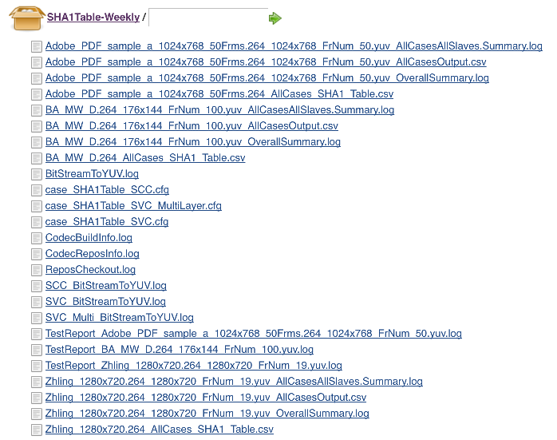

## **2.3 Codec and test tools**

### **2.3.1 Codec for test**

1. **switch to your codec branch and run conformance test**

if you change algorithm or you refactor code, you need to run conformance test for your code change. For example, you push your code change to your repos under branch Algorithm_V1.0,

* + Branch=”Algorithm_V1.0”
  + Repos=” <https://github.com/shihuade/openh264.git>”

and run conformance test on Linux,

you can:

1. modify below parameters in case configuration file

#====================== Git Repository setting ==============

GitAddress  <https://github.com/shihuade/openh264.git>

GitBranch   Algorithm_V1.0

#============================================================

or

1. you can overwrite parameters by passing to run_Main.sh

./run_Main.sh  LocalTest  ./CaseConfigure/case_SVC.cfg  **${ Branch } ${ Repos }**

1. **Update codec by scripts**

* checkout openh264 repos and switch to test branch

more detail, please refer to script files

./run_CheckoutRepos.sh

* build codec with enable YUV dump macro

more detail, please refer to script file

./run_UpdateCodec.sh

* Update flow list as below:

./run_Main.sh

🡺run_PrepareAllTestData.sh

🡺runUpdateCodec()

./run_CheckoutRepos.sh

./run_UpdateCodec.sh

### **2.3.2 App tools for test**

for more detail about test tools, please refer to below files:

* Codec_Linux/Tools32Bits/AboutTools.txt
* Codec_Linux/Tools64Bits/AboutTools.txt

For linux 32 bits test tools, list as below:

#**************************************************************

Tools app build on centos 6.5 32 bits version

i686

#**************************************************************

    ----JMDecoder/DownConvertStatic

        git clone from: https://github.com/shihuade/JSVM.git

        bin file from JSVM/bin/

        with build from JSVM/JSVM/H264Extension/build/linux/

        with default make setting

#**************************************************************

    ----JMDecoder

        git clone from: https://github.com/shihuade/JM.git

        JM19.0

        bin file from JM/bin/

        with build from JM/ with default make setting

#**************************************************************

    ----extractor.app

        from train pangu project

        bin file: under pangu/extractor/build/linux/bin/

        build under pangu/extractor/build/linux/bld/

#**************************************************************

**Tools introduction:**

* DownConvertStatic

Downsample YUV for input test YUV

In Scripts/run_PrepareInputYUV.sh

./DownConvertStatic ${OriginW} ${OriginH} ${OriginYUV}

${OutputW} ${OutputH} ${OutPutYUVFile}"

Truncate frame num

In Scripts/run_TruncateYUV.sh

./DownConvertStatic ${PicW} ${PicH} ${InputYUV}

${PicW} ${PicH} ${OutputYUV}

0 0 0 ${OutputFrmNum}

* JMDecoder

It is for validating encoded bit stream which encoded by test cases, and, check if pass below iterms:

1. Bit stream decoder by JMDecoder successfully
2. Decoded YUV is the same with reconstruction YUV by test encoder

For more detail, please refer to Scripts/run_CheckByJSVMDecoder.sh

* JSVMDecoder

The same with JMDecoder, and support SVC multiple layer cases

For more detail, please refer to Scripts/run_CheckByJSVMDecoder.sh

* extractor.app

extract single layer bit stream from multiple layer cases’ bit stream.

For more detail, please refer to Scripts/run_ExtractLayerBitStream.sh

## **2.4 Test cases**

### **2.4.1 Test case configuration files**

**For Jenkins based test sets assignment configure:**

**in CaseConfigure/, there are 20 cfg files for SVC and SCC test case**

case_Jenkins_SCC_TestSet0.cfg

case_Jenkins_SCC_TestSet1.cfg

case_Jenkins_SCC_TestSet2.cfg

case_Jenkins_SCC_TestSet3.cfg

case_Jenkins_SCC_TestSet4.cfg

case_Jenkins_SCC_TestSet5.cfg

case_Jenkins_SCC_TestSet6.cfg

case_Jenkins_SCC_TestSet7.cfg

case_Jenkins_SCC_TestSet8.cfg

case_Jenkins_SCC_TestSet9.cfg

case_Jenkins_SVC_TestSet0.cfg

case_Jenkins_SVC_TestSet1.cfg

case_Jenkins_SVC_TestSet2.cfg

case_Jenkins_SVC_TestSet3.cfg

case_Jenkins_SVC_TestSet4.cfg

case_Jenkins_SVC_TestSet5.cfg

case_Jenkins_SVC_TestSet6.cfg

case_Jenkins_SVC_TestSet7.cfg

case_Jenkins_SVC_TestSet8.cfg

case_Jenkins_SVC_TestSet9.cfg

**For local /SGE test mode, configure files:**

SVC: case_SCC.cfg

SCC: case_SCC.cfg

**For SHA1 table generation, configure files:**

SCC: case_SHA1Table_SCC.cfg

SVC: case_SHA1Table_SVC.cfg

**For default encode parameters, encoder configure files:**

welsenc.cfg

layer0.cfg

layer1.cfg

layer2.cfg

layer3.cfg

which copied from ${Openh264SrcDir}/testbin

you can refer to script in

scripts/run_UpdateCodec.sh

🡺runCopyFile

all those encode parameters in welenc.cfg and layerx.cfg

will be **overwrited** by parameters in case_xxx.cfg

you can refer to script in

Scripts/run_TestOneCase.sh

🡺runEncodeOneCase()

### **2.4.2 Test case generation**

more detail, please refer to script file

./Scripts/run_GenerateCase.sh

**Brief:**

Combine all test cases in configure file like case_xxx.cfg

And output cvs file which contain all cases

./run_GenerateCase.sh $Case.cfg $TestSequence $OutputCaseFile

for example;

./run_GenerateCase.sh case_SVC.cfg ABC_1920X1080.yuv AllCase.csv

will output all test cases for ABC_1920X1080.yuv based on case_SVC.cfg

output cases csv file may look like:

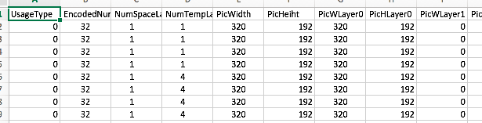

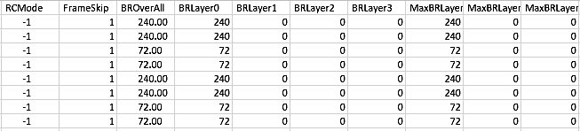

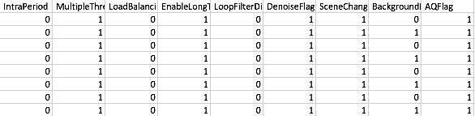

## **2.5 Test data**

### **Test data for one case during test**

When start to run test for one test set, script will go to test space,

* TestSpace=./AllTestData/${TestYUV}
* And all temp files will be output to:

${TestSpace}/${TempDataPath},

which empDataPath=” TempData”

* And all temp files list below

CheckLogFile="${TempDataPath}/CaseCheck.log";

EncoderLog="${TempDataPath}/encoder.log"

RecYUVFile0="${TempDataPath}/${TestYUVName}_rec_0.yuv";

RecYUVFile1="${TempDataPath}/${TestYUVName}_rec_1.yuv"

RecYUVFile2="${TempDataPath}/${TestYUVName}_rec_2.yuv";

RecYUVFile3="${TempDataPath}/${TestYUVName}_rec_3.yuv"

RecCropYUV0="${TempDataPath}/${TestYUVName}_rec_0_cropped.yuv";

RecCropYUV1="${TempDataPath}/${TestYUVName}_rec_1_cropped.yuv"

RecCropYUV2="${TempDataPath}/${TestYUVName}_rec_2_cropped.yuv";

RecCropYUV3="${TempDataPath}/${TestYUVName}_rec_3_cropped.yuv"

For more detail, please refer to script

*run_TestAssignedCases.sh*

*run_TestOneCase.sh*

### **Test data for one test cases set**

1. **One test cases set is sub-set of all test cases for one YUV.**

For example, for desktop_dialog_1920x1080_i420.yuv

* In case_SCC.cfg, oveall test cases is num 10368
* In case_Jenkins_SCC_TestSet0.cfg, test case num is 2592

When run below command in local test machine:

./run_Main.sh LocalTest case_Jenkins_SCC_TestSet0.cfg

only sub-set of 2592 cases of all 10368 cases.

1. **Test data files for one test set is under ResultPath and IssueDataPath,**

* TestSpace=./AllTestData/${TestYUV}
* ResultPath=${ TestSpace }/result
* IssueDataPath=${ TestSpace }/issue

For more detail, please refer to script

*run_TestAssignedCases.sh*

Below is part of script for test data path setting in *run_TestAssignedCases.sh*

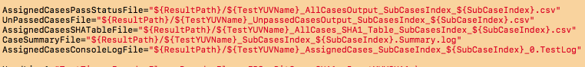

Below is test result files for CiscoVT2people_320x192_12fps.yuv

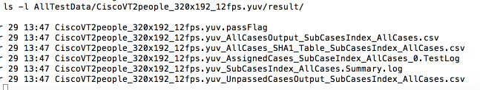

For subcase index,

* SGE test mode: index = 0, 1, 2, …
* Local test mode: index = AllCases

For more detail, please refer to run_CasesPartition.sh

1. **For all sub test cases console output, you can refer to**

AssignedCasesConsoleLogFile

Below is test console output for CiscoVT2people_320x192_12fps.yuv

For each cases, there is detail console output log include:

* Test cases detail parameters
* Encoder log, include encoder command line, encoder output
* Encoder reconstruction YUV’s check
* JSVM/JM check log
* Wlsdecoder check log
* Final check summary info

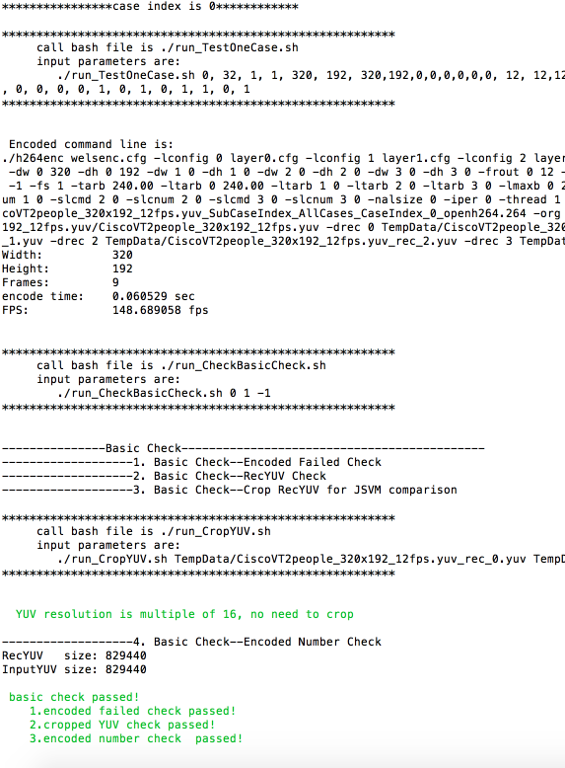

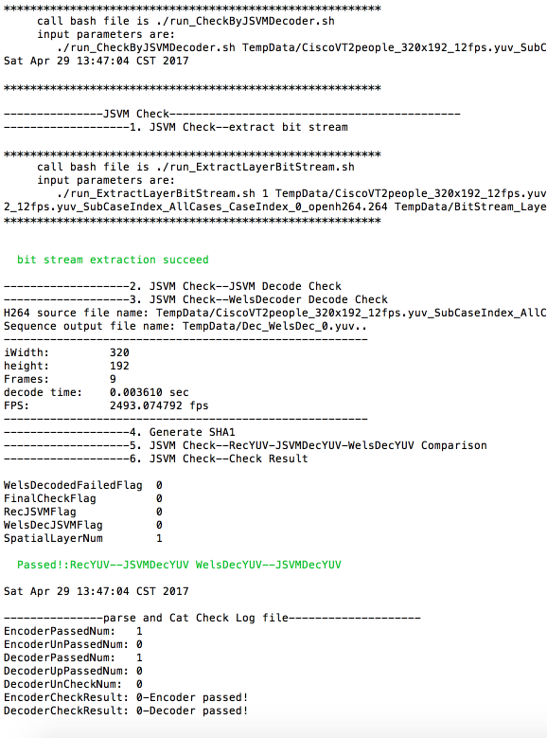

### **2.5.3 How to reproduce failed case**

1. **Reproduce based on console output log**

As mentioned in #3, there are console output log for each case,

you can find out the root cause for failed cases, and run that failed case step by step based on log

1. **Reproduce based on csv file**

Below is test result files for CiscoVT2people_320x192_12fps.yuv

Scv file: CiscoVT2people_320x192_12fps.yuv_AllCasesOutput_SubCasesIndex_AllCases.csv

Include all test cases status and encoder command line.

You can run that cases with:

* encoder command
* using JSVM/JM to decode bit stream
* check decoded YUV which decoded by JSVM/JM/Welsdecoder
* validate bit stream and YUVs

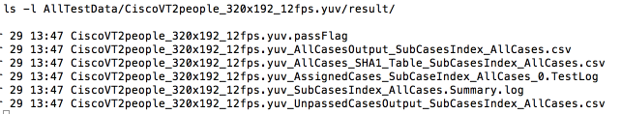

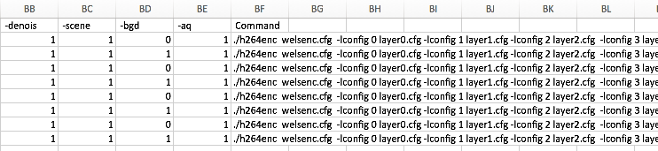

### **2.5.4 Test data for all YUVs**

During running test cases and after completed all test cases for one YUVs,

test result files are in ./FinalResult directory.

1. **Below is example for only one YUV in test**

* test YUV is CiscoVT2people_320x192_12fps.yuv
* test set num is 1

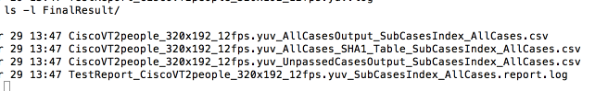

if there are 4 set for CiscoVT2people_320x192_12fps.yuv,

the result file may looks like:

CiscoVT2people_320x192_12fps.yuv_AllCasesOutput_SubCasesIndex_0.csv

CiscoVT2people_320x192_12fps.yuv_AllCasesOutput_SubCasesIndex_1.csv

CiscoVT2people_320x192_12fps.yuv_AllCasesOutput_SubCasesIndex_2.csv

CiscoVT2people_320x192_12fps.yuv_AllCasesOutput_SubCasesIndex_3.csv

CiscoVT2people_320x192_12fps.yuv_AllCases_SHA1_Table_SubCasesIndex_0.csv

CiscoVT2people_320x192_12fps.yuv_AllCases_SHA1_Table_SubCasesIndex_1.csv

CiscoVT2people_320x192_12fps.yuv_AllCases_SHA1_Table_SubCasesIndex_2.csv

CiscoVT2people_320x192_12fps.yuv_AllCases_SHA1_Table_SubCasesIndex_3.csv

CiscoVT2people_320x192_12fps.yuv_UnpassedCasesOutput_SubCasesIndex_0.csv

CiscoVT2people_320x192_12fps.yuv_UnpassedCasesOutput_SubCasesIndex_1.csv

CiscoVT2people_320x192_12fps.yuv_UnpassedCasesOutput_SubCasesIndex_2.csv

CiscoVT2people_320x192_12fps.yuv_UnpassedCasesOutput_SubCasesIndex_3.csv

TestReport_CiscoVT2people_320x192_12fps.yuv_SubCasesIndex_0.report.log

TestReport_CiscoVT2people_320x192_12fps.yuv_SubCasesIndex_1.report.log

TestReport_CiscoVT2people_320x192_12fps.yuv_SubCasesIndex_2.report.log

TestReport_CiscoVT2people_320x192_12fps.yuv_SubCasesIndex_3.report.log

1. **Below is the final test result setting in scripts**

*run_Main.sh*

*🡺runMain()*

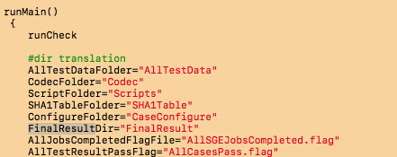

*run_Main.sh*

*🡺runMain()*

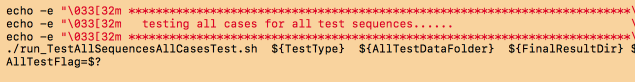

*run_AllTestSequencesAllCasesTest.sh*

*🡺runLocalTest*

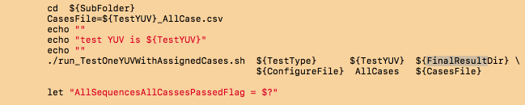

*run_TestOneYUVWithAssignedCases.sh*

*🡺runGlobalVariableInitial*

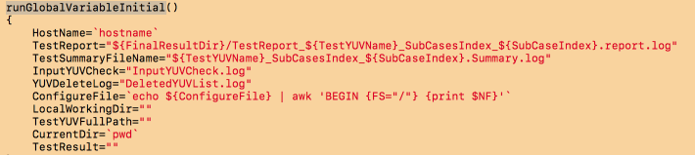

## **2.6 Test report**

After all test cases for all YUVs have been completed,

final test result and report for all YUVs will be generated

and create under directory

./FinalTestReport

1. **Below is example for only one YUV in test,**

test YUV is CiscoVT2people_320x192_12fps.yuv

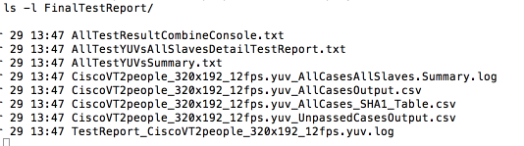

output of TestReport_CiscoVT2people_320x192_12fps.yuv.log

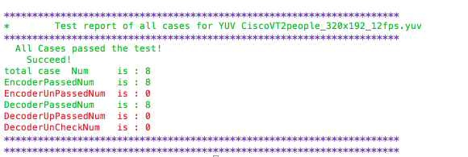

output of AllTestYUVsAllSlavesDetailTestReport.txt

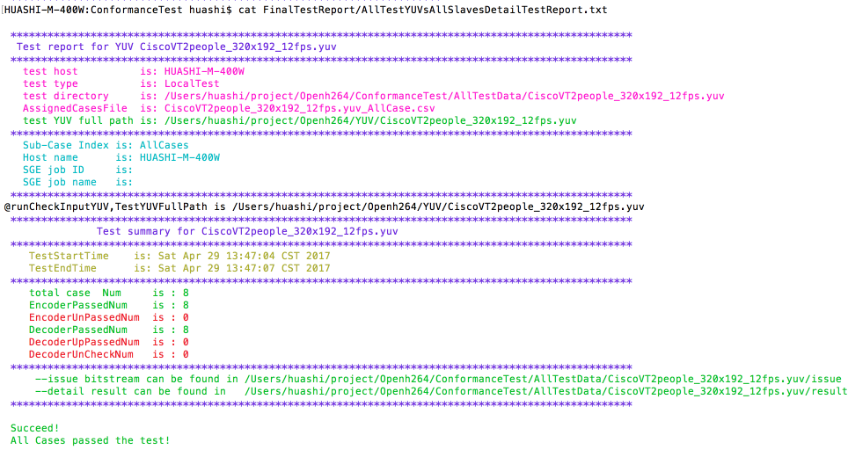

1. **Below is the final test report directoty setting in scripts**

*run_GetAllTestResult.sh*

*🡺runMain()*

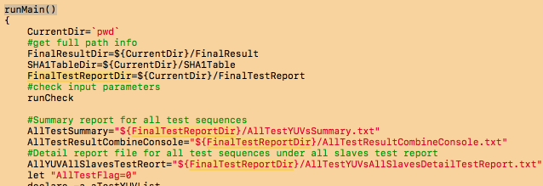

*run_GetAllTestResult.sh*

*🡺runGetAllYUVTestResult*

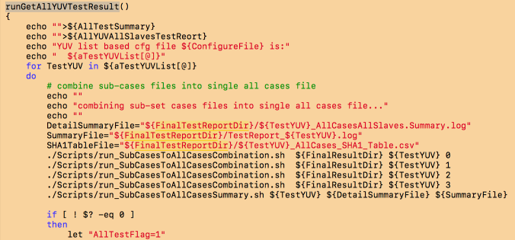

## **Basic flow chart for test preparation**

### 2.7.1 basic flow chart

More detail, please refer to script file

*run_PrepareAllTestFolder.sh*



### Example

1. **Below is example after updating codec**

all codec and test tools will be copied to

./Codec folder

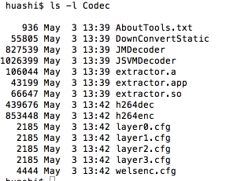

1. **Below is example for removing previous test data and update codec**

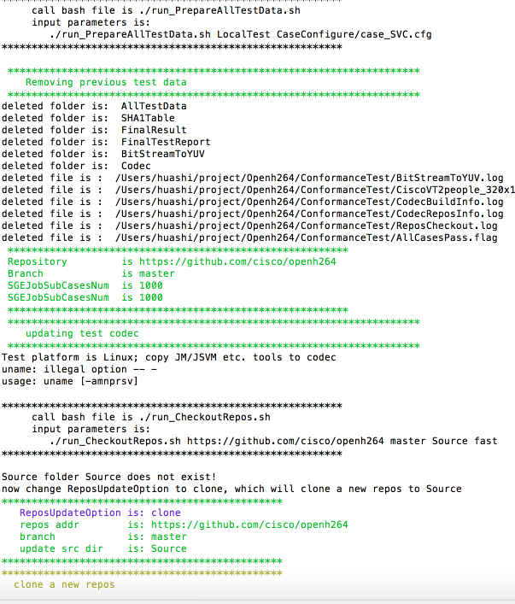

1. **Below is example after preparing all test space for all YUVs**

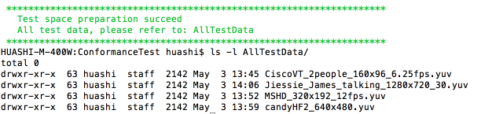

1. **Below is example after preparing all test space for all YUVs**

**Take** Jiessie_James_talking_1280x720_30.yuv **for example,**

**Test space is:**

AllTestData/Jiessie_James_talking_1280x720_30.yuv/

**And files before run all test cases include:**

* **Encoder configure file welsenc.cfg etc.**
* **Codec app, JM app etc**
* **All test script files**
* **Csv format test cases file**

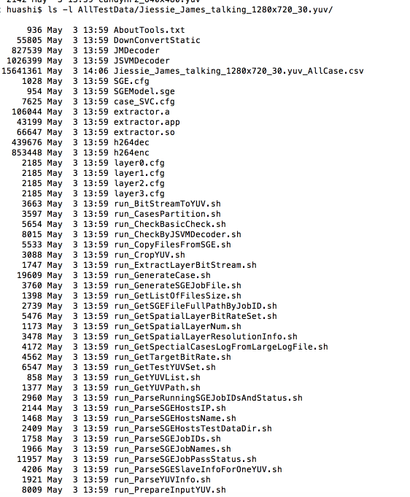

## Basic flow chart for testing all cases

More detail, please refer to script file

*run_TestAllSequencesAllCasesTest.sh*

### **2.8.1 Test all cases for all YUVs**



### **2.8.2 Test assigned cases within one test cases set for one YUV**

More detail, please refer to script file

*run_TestOneYUVWithAssignedCases.sh*

*run_TestAssignedCases.sh*

*run_PrepareInputYUV.sh*



### **2.8.3 Test one case**

More detail, please refer to script file

*run_TestOneCase.sh*

*run_CheckBasicCheck.sh*

*🡺 run_CropYUV.sh*

*run_CheckByJSVMDecoder.sh*

*🡺 run_ExtractLayerBitStream.sh*

**

## 2.9 Basic flow chart for check final test result

More detail, please refer to script file

*run_GetAllTestResult.sh*

*run_SubCasesToAllCasesSummary.sh*



# **Jenkins based conformance test**

## **Basic test architecture**



**Current Jenkins slaves for conformance test in HZ site**



## **Test set and Jenkins slaves task assignment**



**Test set for SCC/SVC:**

**in CaseConfigure/, there are 20 cfg files for SVC and SCC test case**

case_Jenkins_SCC_TestSet0.cfg

case_Jenkins_SCC_TestSet1.cfg

case_Jenkins_SCC_TestSet2.cfg

case_Jenkins_SCC_TestSet3.cfg

case_Jenkins_SCC_TestSet4.cfg

case_Jenkins_SCC_TestSet5.cfg

case_Jenkins_SCC_TestSet6.cfg

case_Jenkins_SCC_TestSet7.cfg

case_Jenkins_SCC_TestSet8.cfg

case_Jenkins_SCC_TestSet9.cfg

case_Jenkins_SVC_TestSet0.cfg

case_Jenkins_SVC_TestSet1.cfg

case_Jenkins_SVC_TestSet2.cfg

case_Jenkins_SVC_TestSet3.cfg

case_Jenkins_SVC_TestSet4.cfg

case_Jenkins_SVC_TestSet5.cfg

case_Jenkins_SVC_TestSet6.cfg

case_Jenkins_SVC_TestSet7.cfg

case_Jenkins_SVC_TestSet8.cfg

case_Jenkins_SVC_TestSet9.cfg

For more detail about test set, please refer to:

AboutJenkinsTestSet.txt

## **Jenkins jobs**

**Jenkins job, please refer to:**

[**http://10.140.198.27:8080/view/ConformanceTest/job/OpenH264-Encoder-Conformance-Test/**](http://10.140.198.27:8080/view/ConformanceTest/job/OpenH264-Encoder-Conformance-Test/)

<http://10.140.198.27:8080/job/OpenH264_ConformanceTest_SCC_TestSet0/configure>

## **Test data and test report**

For test result of each test set, you can refer to job artifact,

which show as below:

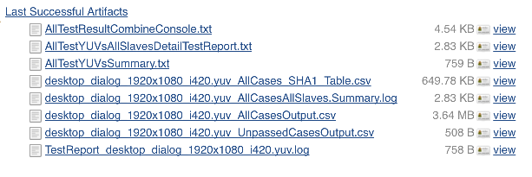

## **Failed cases reproduce and analysis**

### **Please refer to 2.5.3 How to reproduce failed case**

# **SGE based conformance test**

## **Basic test architecture**

For how to install and configure SGE system, please refer to

Charpter SGE install and configuration



**Current SGE in HZ**

HuangZhong

ZhangFei

GuanYu

ZhaoYun

SGE Master

LiuBei

MaDai

JiangWei

MaChao

## **Test set and Jenkins slaves task assignment**

### **4.2.1 Basic module**

Job 1

SGE Slave A

**Job submit**

SGE Master

Job 2

SGE Slave B

Job Management

Job ..

......

Job n

SGE Slave n



### **4.2.2 Basic SGE Test flowchart**

Post-Test Module

Run-Test Module

Pre-Test Module

Codec Update

Jobs submit

Job status update

Test data files copy

All Test Summary

Sub2All Summary

Cases Generation

Jobs-based cases Test

Cases Partition

Cases Validation

Test Space preparation

Job-based Summary

Test data Backup

Jobs Preparation

## **4.3 Pre-Module of SGE Test**

Pre-Test Module

Git clone latest/given repository code

Codec Update

Build codec,Replace previous codec

Generate cases based on configure file

case.cfg

Cases Generation

Openh264-based cases validate module

Split all test cases set into small sub-set

Cases Partition

Sub-Set Cases 0

YUV 0 test space

YUV n test space

…

YUV 1 test space

Test Space preparation

Test Data

Test Data

Test Data

YUV n test space

…

YUV 1 test space

All Test YUVs

YUV 0 test space

All Test Cases

Sub-Set Cases ..

…

Sub-Set Cases 1

Job 0

Sub cases n

….

Sub cases 0

…

Jobs Preparation

Job n

Job n+1

Sub cases n

….

Sub cases 0

…

**4.4 Test Module of SGE Test**

Job n+n

Run-Test Module

Submit jobs to master

Jobs submit

YUV based job priority setting

Search Test YUV files in local slave

Jobs-based cases Test

Environment setting based on local slave

Test preparation based on local slave

Encoded failed detection

Single layer

JM-Decoder-Encoder YUV Comparison

Decoder decoded Validation

JM decoded Validation

Cases Validation

Multiple layer

Generate SHA1 string of bit stream

Failed cases bit stream backup

Sub cases test result summary(job-based)

Job-based Summary

SHA1 files(all sub cases’ SHA1 string)

Detail result file for all sub cases

Test log file for all sub cases

## **4.5 Post-Module of SGE Test**

Post-Test Module

Check that if all jobs have been completed

Check which jobs are still running

Job status update

Output job status info

Sub cases 0 summary

All summary

Sub cases n summary

….

Sub cases n summary

….

Sub cases 0 summary

All summary

YUV 1

YUV 0

YUV n

…

Sub2All Summary

YUV 0 All Summary

YUV n All Summary

…

YUV 1 All Summary

All Test Summary

All cases of all test sequences’ summary

## **4.6 Jenkins jobs for SGE test**

Test data Backup

Backup all test result data in backup server

### **4.6.1 Period SGE submit**

more detail, please refer to Jenkins job

<http://10.140.198.27:8080/view/SGE-Test/job/Openh264-SGE-Job-Submit/configure>

Jenkins

Weekly/or 2 weeks

Submit test jobs to SGE

### **SGE test status detection jobs**

more detail, please refer to Jenkins job

<http://10.140.198.27:8080/view/SGE-Test/job/Openh264-SGE-Job-status-And-TestResult/configure>

Daily check

When all jobs have been completed, get final test result and summary

Jenkins

## **Test data and test report**

For test report of each SGE submit,

you can refer to job artifact to get all test report and log files

<http://10.140.198.27:8080/view/SGE-Test/job/Openh264-SGE-Job-status-And-TestResult/lastSuccessfulBuild/artifact/Openh264-SGETest/Jenkins-Job-Status-Check-Log/>

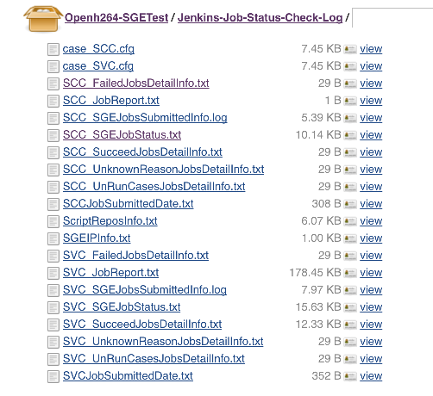

## **Failed cases reproduce and analysis**

Please refer to **2.5.3 How to reproduce failed case**

# **SHA1 tables generation**

## **basic arch**



**basic validate logic**



## **5.2 setting in case configure file**

In CaseConfureFile/*.cfg, like:

* ./CaseConfigure/case_SHA1Table_SCC.cfg
* ./CaseConfigure/case_SHA1Table_SVC.cfg

chane InputFormat to 1, and bitstream directory is Source/res

#===========  Test Input bit stream/TestSequence setting=================

TestBitStreamDir:    Source/res       #  derectory of input test bit stream files

InputFormat:   1       #Input file format, 0:YUV file; 1 bit stream file,

#=================================================================

## **SHA1 tables for openh264 travis test**

1. SHA1 tables for openh264

* OpenH264/test/encoder_binary_comparision
* <https://github.com/cisco/openh264/tree/master/test/encoder_binary_comparison/SHA1Table>

1. Travis test

Travis test setting:

https://github.com/cisco/openh264/blob/master/.travis.yml

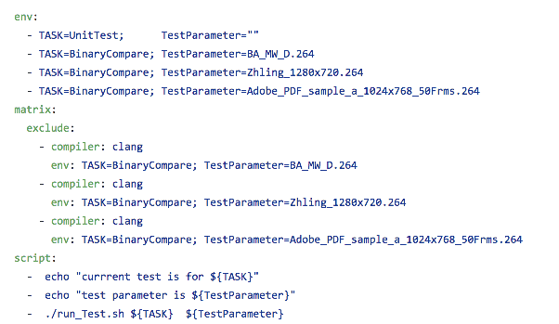

**Called by OpenH264/run_Test.sh**

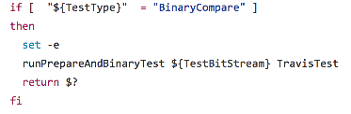

**Travis test for one bit stream**

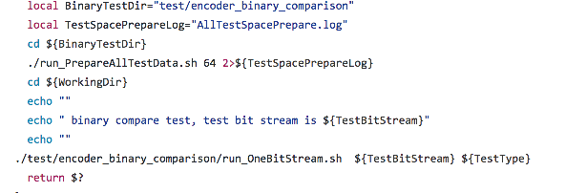

**Travis test script for SHA1 validation**

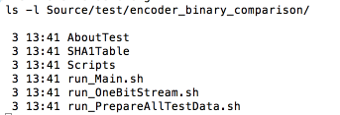

## **Jenkins job**

1. Jenkins job will generate SHA1 table for given bit stream setting in

case_SHA1Table_SCC.cfg file

1. for more detail, please refer to Jenkins job

<http://10.140.198.27:8080/job/Openh264_Travis_SHA1Table_Generation_weekly/configure>

1. You can update your branch’s SHA1 tables

when you change code which may lead to bit steam change

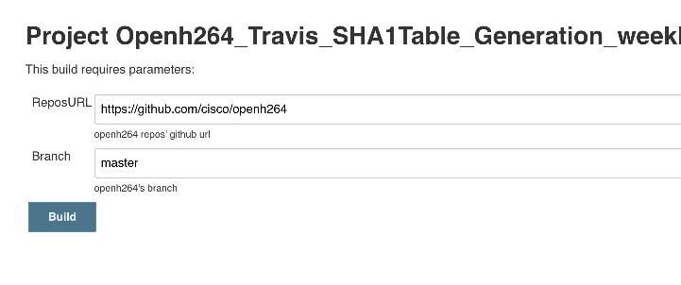

1. for SHA1 tables, you can download from job’s artifact

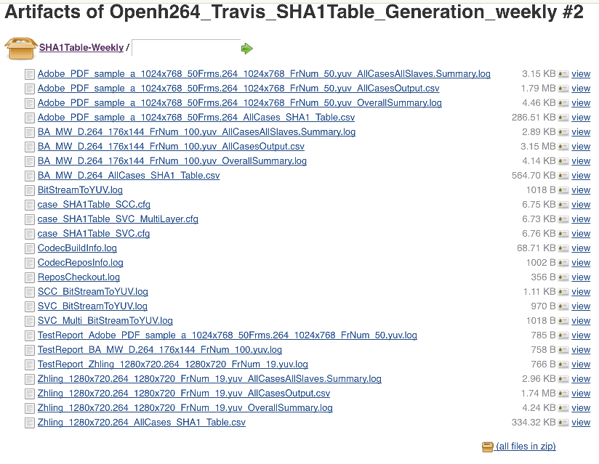

# **SGE install and configuration**

#### **The following is an introduction of the installation SGE**

#### **This chapter is copied from video team’s SGE installation and configuration documents**

## **6.1 Install sge-qmaster**

1. update these packages to make sure the consistency of system environment with other hosts.
   1. yum install *gcc*
   2. yum install *make*
   3. yum install *gnuplot*
   4. yum install *glibc*
   5. uname –a -------to check the kernel version is same as other hosts, otherwise

yum install *kernel*

* 1. Reboot system

1. download the package:

sge62u2_1_linux24-i586_targz.zip from sun website

1. decompression this package in xp. Then download the two tar files to your centos machine.
2. Mkdir /opt/sge62u2_1

then use

tar zxvf sge-6_2u2_1-bin-linux24-i586.tar.gz

tar xzvf sge-6_2u2-common.tar.gz

1. Useradd –g root –u 501 sgeadmin
2. Vi /etc/hosts

# Do not remove the following line, or various programs

# that require network functionality will fail.

#127.0.0.1      localhost.localdomain   localhost

127.0.0.1       localhost0.localdomain  localhost0

10.224.204.26 sge-qmaster.webex.com sge-qmaster

1. vi /etc/sysconfig/network

NETWORKING=yes

NETWORKING_IPV6=no

HOSTNAME=sge-qmaster

1. Remove the krb5-workstation package of rsh

rpm -qf `which rlogin` this command is to check rsh version.

rpm -e krb5-workstation remove the krb5-workstation package.

1. Install a latest version of rsh:
   1. yum install rsh
   2. 运行setup，进入系统服务，将rsh/rlogin/rexec选中，退出
   3. 查看/etc/xinetd.d目录下有没有rsh、rexec、rlogin文件，若没有，请添加，内容请参考第一大步骤3小步骤
   4. 若/etc/xinetd.d目录下有rsh、rexec、rlogin文件，vi /etc/xinetd.d/rs,将disable = yes改为disable = no（受控端设置）
   5. 若服务器设置了防火墙，请打开512\513\514端口（受控端设置）
   6. 修改配置文件（受控端设置）
   7. #vi /etc/securetty再里面添加rsh rexec rlogin。   
      或者   
      #echo "rexec" >>/etc/securetty   
      #echo "rlogin" >>/etc/securetty   
      #echo "rsh" >>/etc/securetty
2. Install a latest version of rsh:

vi /root/.bash_profile: PATH=$PATH:$HOME/bin:/opt/sge62u2_1:/opt/sge62u2_1/bin/lx24-x86:/opt/SDK/bin:/opt/SDK

SGE_ROOT=/opt/sge62u2_1;export SGE_ROOT

SGE_CELL=SVC_SGE1;export SGE_CELL

SGE_QMASTER_PORT="10536";export SGE_QMASTER_PORT

SGE_EXECD_PORT="10537";export SGE_EXECD_PORT

JAVA_HOME=/opt/SDK;export JAVA_HOME

PATH=$PATH:$SGE_ROOT/bin

export PATH

unset USERNAME

note: you need to install Java and change the JAVA_HOME to /opt/SDK

1. Restart  .bash_profile:

.  .bash_profile

1. service network restart
2. service xinetd restart
3. cd /opt/sgeu62u2_1/
4. ./install_qmaster

(follow the instruction and use default setting)

## **6.2 Install sge-host**

1. update these packages to make sure the consistency of system environment with other hosts.
   1. yum install *gcc*
   2. yum install *make*
   3. yum install *gnuplot*
   4. yum install *glibc*
   5. uname –a -------to check the kernel version is same as other hosts, otherwise

yum install *kernel*

* 1. Reboot system

1. Change the computer name or host name like Carl, Jeny….
   1. Vi /etc/sysconfig/network            HOSTNAME=Yula
2. Remove the krb5-workstation package of rsh
   1. rpm -qf `which rlogin` this command is to check rsh version.
   2. rpm -e krb5-workstation remove the krb5-workstation package.
3. Install a latest version of rsh:
   1. yum install rsh (sometime you need to yum install xinetd firstly)
   2. 命令行输入 setup,进入系统服务，将rsh/rlogin/rexec选中，save,退出；
   3. 查看/etc/xinetd.d目录下有没有rsh、rexec、rlogin文件，如果有，表明rsh安装成功；
   4. 若/etc/xinetd.d目录下有rsh、rexec、rlogin文件，vi /etc/xinetd.d/rsh,将disable = yes改为disable = no（受控端设置）；
   5. 若服务器设置了防火墙，请打开512\513\514端口（受控端设置）；
   6. 命令行输入 setup,进入防火墙配置，关闭防火墙；
   7. 修改配置文件/etc/securetty ，在文件最后添加 rsh, rexec ,rlogin

Echo “rexec">>/etc/securetty

Echo “rlogin">>/etc/securetty

Echo "rsh" >>/etc/securetty

1. Add ports permission in        /etc/services
   1. Echo “###SGE service”>> /etc/services
   2. Echo “sge_qmaster 10536/tcp”>> /etc/services
   3. Echo “sge_execd 10537/tcp”>>/etc/services
2. SGE install package preparation
   1. Download the package: sge62u2_1_linux24-i586_targz.zip from sun website
   2. Decompression this package in xp. Then download the two tar files to your centos machine.
   3. Mkdir /opt/sge62u2_1 the use tar zxvf sge-6_2u2_1-bin-linux24-i586.tar.gz       tar xzvf sge-6_2u2-common.tar.gz
   4. Useradd –g root –u 501 sgeadmin
   5. Mkdir SVC_SGE1 (sell name) all machines should have this directory.
   6. Chmod 777 SVC_SGE1.
   7. Mkdir SGE_room2 (sell name) all machines should have this directory.
   8. Chmod 777 SGE_room2.
   9. Mount the directory.

Mount 10.224.204.26:/opt/sge62u2_1/SVC_SGE1/  /opt/sge62u2_1/SVC_SGE1/

Mount 10.224.204.26:/opt/sge62u2_1/SGE_room2/  /opt/sge62u2_1/SGE_room2/

Note: you need to start you NFS service.

--sge-master side: /etc/init.d/rpcbind restart

--sge-host side: /etc/init.d/nfs restart

If above command does not work, try to change the NFS setting in **sge-master** side as below:

Vi /etc/exports and add host info

#for ZhangFei

/opt/sge62u2_1/SVC_SGE1/ 10.224.200.95(rw,no_root_squash)

/opt/sge62u2_1/SGE_room2/ 10.224.200.95(rw,no_root_squash)

#for ZhaoYun

/opt/sge62u2_1/SVC_SGE1/ 10.224.200.124(rw,no_root_squash)

/opt/sge62u2_1/SGE_room2/ 10.224.200.124(rw,no_root_squash)

1. Modify /root/.bash_profile:
   1. Add these lines at the end of /root/.bash_profile

 PATH=$PATH:$HOME/bin:/opt/sge62u2_1:/opt/sge62u2_1/bin/lx24-x86:/opt/SDK/bin:/opt/SDK

SGE_ROOT=/opt/sge62u2_1;export SGE_ROOT

SGE_CELL=SVC_SGE1;export SGE_CELL

SGE_QMASTER_PORT="10536";export SGE_QMASTER_PORT

SGE_EXECD_PORT="10537";export SGE_EXECD_PORT

JAVA_HOME=/opt/SDK;export JAVA_HOME

PATH=$PATH:$SGE_ROOT/bin

export PATH

unset USERNAME

* 1. Restart  .bash_profile:

.  .bash_profile

1. update /etc/host related files:
   1. 转到**sge-qmaster(10.224.204.26),** 在/etc/hosts 文件中加入新机器的ip地址与host name 列表：

127.0.0.1 localhost0.localdomain localhost0

10.224.204.26 sge-qmaster.webex.com sge-qmaster

10.224.174.14 Dena

10.224.174.18 High

10.224.174.19 Jeny

10.224.174.20 Yula

10.224.174.21 Gaea

10.224.174.22 Eros

10.224.174.23 Rhea

10.224.174.24 Hera

::1  localhost6.localdomain6 localhost6

* 1. **在本机上，**同样在/etc/hosts 文件中加入新机器的ip地址与host name 列表

127.0.0.1 localhost.localdomain localhost

10.224.204.26 sge-qmaster.webex.com   sge-qmaster

10.224.174.14 Dena

10.224.174.18 High

10.224.174.19 Jeny

10.224.174.20 Yula

10.224.174.21 Gaea

10.224.174.22 Eros

10.224.174.23 Rhea

10.224.174.24 Hera

::1    localhost6.localdomain6 localhost6

* 1. **在本机上**，在/etc/hosts.allow文件中加入如下信息：

in.rshd:10.224.204.26 root pass789

in.rlogind:10.224.204.26 root pass789

portmap:10.224.204.26 root pass789

sshd:10.224.204.26 root pass789

1. 转到**sge-qmaster(10.224.204.26)**， 使用 qconf –ah 命令，添加新的SGE host PC:
   1. qconf –ah  Yula.
2. service network restart

service xinetd restart

note: you need to remount the folder again:

Mount 10.224.204.26:/opt/sge62u2_1/SVC_SGE1/  /opt/sge62u2_1/SVC_SGE1/

Mount 10.224.204.26:/opt/sge62u2_1/SGE_room2/  /opt/sge62u2_1/SGE_room2/

如果 mount 有问题，请参考 步骤6

如果xinetd 没有安装，yum install xinetd

1. cd /opt/sgeu62u2_1/
2. ./ install_execd
3. Make sure sgeadmin in all machine should have same ID, same group.  Check environment variable of sgeadmin. Should be same with root. (this is very important. And this block us too much time to solve it.)

## **6.3 Sge 断电重启方法**

**Sge-master:10.224.204.26:**

1. cd /opt/sge62u2_1/SVC_SGE1/common

2. ./sgemaster start

**Sge-host: 10.224.174.1x**

1.mount 10.224.204.26:/opt/sge62u2_1/SVC_SGE1/ /opt/sge62u2_1/SVC_SGE1/

2.mount 10.224.204.26:/opt/sge62u2_1/ SGE_room2/ /opt/sge62u2_1/ SGE_room2/

3.cd /opt/sge62u2_1/SVC_SGE1/common

4. ./sgeexecd start

5.检查sge 是否正在运行使用命令: ps -ef | grep sge

**自动化重启脚本**

当前在杭州的机器，/root/目录下已经有写好的自动重启SGE的脚本。

--run_SGERestart_For_Host_side.sh（放在各host的/root/目录下）

--run_SGERestart_Master_side.sh(放在master的/root目录下)

1. 在SGE-master,可以按照提示，可以在master端重启master和host.

（各host 的IP 在脚本run_SGERestart_Master_side.sh里，可以根据实际IP来增减；

同时要确保脚本run_SGERestart_For_Host_side.sh放在各host的/root/目录下）

2. 在host的机器，也可以单独运行脚本，单个重启host.

3. 如果在mount 上遇到问题，请参考 host 装的第6步的解决方法。

## **6.4 Sge 常用命令**

1.submit host

* Qconf –as hostname add new host to submit list
* Qconf –ds hostname delete host from the submit list
* As defaut, we used sge-master as submot host,

If you submit a job by qsub Xxjob, there is error info 'unable to run job: host sge-master is no submit host' or something like that:

Just use qconf –as sge-master to add sge-master to the submit host list. You can also add another host to the submit host list, and thus this host can also use command qsub XXXjob to submit job

2.queue management

* Qconf –sql list all of the queue
* Qconf –sq queuename list the detail info of queue
* Qconf –aq queuename add new queue
* Qconf –dq queuename delete queue
* Qconf –mq quenename modify the queue parameters,e.g.priority etc.
* Example of qconf –mq Openh264 for adding host in this test queue

qname Openh264

hostlist ZhangFei GuanYu ZhaoYun MaChao HuangZhong MaDai JiangWei

seq_no 0

load_thresholds np_load_avg=1.75

suspend_thresholds NONE

3.jop managment

* Qstat –f list all avaliable host and host status
* Qstat list all job (running/queue/waiting)
* Qdel JobId delete job
* Qsub job job should be as a excutable bianry file or script file
* Qsub –q qname job run job under destianted queue
* For more info about submit a job, you can refer to helo info by qsub –help

4. Other command :

* Qmod –s
* ...

**6.5 Test-bed 一致性测试说明**

一致性测试testbed路径:

10.224.204.26: /opt/sge62u2_1/SGE_room2/Wels_Codec_Test

测试序列:

为了避免在SGE运行中对于sge-master硬盘中视频序列数据的海量读取，在每一台sge-host的/opt路径下都存放了一份测试序列的拷贝，如Hera这台sge-host的序列路径为/opt/Hera/Test_sequence，所以如果要增加测试序列，需要在sge-master的测试序列路径/opt/sge62u2_1/SGE_room2/Wels_Codec_Test/Test_sequence以及每一台sge-host的测试序列路径下都存放一份拷贝。

1. Wels_SVC_decoder_test: decoder一致性测试(3D4Q)

操作说明:

* 1. 将需要测试的decoder重新命名为h264dec.exe 并拷贝到该路径下；
  2. 运行命令sh run.sh

1. Wels_SVC_encoder_compare: 在同样的编码条件下，在固定QP编码条件下，检查两个不同的encoder编码结果是否一致(3D2Q)

操作说明:

* 1. 将需要测试的两个encoder拷贝到路径/opt/sge62u2_1/SGE_room2/Wels_Codec_Test/Wels_SVC_encoder_compare/Wels_SVC_encoder_test下;
  2. 重新命名两个encoder文件，一个命名为h264enc_opt_b.exe，另外一个命名为h264enc_per_t.exe;
  3. 运行命令sh run_no_mgs_slice_compare.sh

1. Wels_SVC_encoder_compare_rc_on: 在同样的编码条件下，Rate control 打开的情况下，检查两个不同的encoder编码结果是否一致(3D2Q)
   1. 将需要测试的两个encoder拷贝到路径/opt/sge62u2_1/SGE_room2/Wels_Codec_Test/Wels_SVC_encoder_compare_rc_on/Wels_SVC_encoder_test下；
   2. 重新命名两个encoder文件，一个命名为h264enc_opt_b.exe，另外一个命名为h264enc_per_t.exe;
   3. 运行命令sh run_no_mgs_slice_compare.sh
2. Wels_SVC_encoder_HD_test: HD encoder一致性测试(1D1Q)
   1. 将需要测试的encoder拷贝到路径/opt/sge62u2_1/SGE_room2/Wels_Codec_Test/Wels_SVC_encoder_HD_test/Wels_SVC_en_AVC_case 下
   2. 重新命名encoder文件，命名为h264enc.exe
   3. 运行命令sh Wels_SVC_en_AVC_case.sh(增加svc基本测试,已添加)
3. Wels_SVC_encoder_MT_test: 在Multi-thread的编码条件下，测试encoder的一致性(3D2Q)
   1. 将需要测试的两个encoder拷贝到路径/opt/sge62u2_1/SGE_room2/Wels_Codec_Test/Wels_SVC_encoder_MT_test下，其中一个encoder 的multi-thread编码选项关闭，命名为h264enc_noMT.exe， 另外一个encoder的multi-thread编码选项打开，命名为h264enc_MT.exe
   2. 运行命令sh run_no_mgs_slice_MT.sh
4. Wels_SVC_encoder_test: encoder 一致性测试，其中针对mgs的测试包含1个base quality layer 和3个enhancement quanlity layers(fix qp)(3D4Q)
   1. 将需要测试的encoder拷贝到路径/ /opt/sge62u2_1/SGE_room2/Wels_Codec_Test/Wels_SVC_encoder_test 下
   2. 重新命名encoder文件，命名为h264enc.exe
   3. 运行命令sh run_no_mgs_slice.sh
5. Wels_SVC_encoder_test_cvs_algo: 针对cvs algo_tune_b branch的encoder 一致性测试，其中针对mgs的测试包含1个base quality layer 和1个enhancement quanlity layers(3D2Q)
   1. 将需要测试的encoder拷贝到路径/ /opt/sge62u2_1/SGE_room2/Wels_Codec_Test/Wels_SVC_encoder_test_cvs_algo 下
   2. 重新命名encoder文件，命名为h264enc.exe
   3. 运行命令sh run_no_mgs_slice.sh
6. Wels_SVC_encoder_test_svn_opt_tune: 针对SVN opt_tune_b branch的encoder 一致性测试，其中针对mgs的测试包含1个base quality layer 和1个enhancement quanlity layers(3D2Q)
   1. 将需要测试的encoder拷贝到路径/ /opt/sge62u2_1/SGE_room2/Wels_Codec_Test/Wels_SVC_encoder_test_svn_opt_tune 下
   2. 重新命名encoder文件，命名为h264enc.exe
   3. 运行命令sh run_no_mgs_slice.sh
   4. 测试结果在相应的result_check路径下查找。
7. Wels_SVC_encoder_test_rc_on: 在rate control模块打开的情况下，针对encoder 一致性测试(3D2Q)
   1. 将需要测试的encoder拷贝到路径/ /opt/sge62u2_1/SGE_room2/Wels_Codec_Test/Wels_SVC_encoder_test_rc_on 下
   2. 重新命名encoder文件，命名为h264enc.exe
   3. 运行命令sh run_rc_on.sh

## **6.6. Test-bed performance 测试说明：**

工作路径为：

/opt/sge62u2_1/SGE_room2/Wels_Codec_Test/Wels_SVC_opt_encoder_performance_test/testbed

运行命令为:

sh testbed.sh *.para

qp_multi_spatial_vs_singlelayer_vs_simlcast.para: RD performance comparison among SVC multi-spatial layer coding and single layer coding for the highest resolution picture and simulcast multi-spatial layer coding.

Wels_vs_VP8_rc_30HZ_360p.para: RD performance comparison among Wels encoder and x264 encoder and VP8 encoder.

HD_720p_test.para RD: performance analyzing for HD encoder at the condition of fixed QP coding.

HD_720p_test_rc.para: RD performance analyzing for HD encoder at the condition of rate control module turned on

qp_diff_qp_cascading_gop148_rc_24HZ_360p.para: temporal scalable coding performance testing

#### ffmpeg

de-mux使用命令：

ffmpeg -i h264.mp4 -vcodec copy -vbsf h264_mp4toannexb -an out.h264

*.*🡪yuv使用的命令：

ffmpeg -i input.avi output.yuv

re-sample使用命令：

ffmpeg -s 1920x1080 -i Absolute_Power.yuv -s 1280x720 Absolute_Power_720p.yuv”

Should be noted out that for raw YUV format input, the file name must be ended by “.yuv” otherwise the ffmpeg down-scale tool can not recognize the input format.

update version

ffmpeg 更新或者下载某个版本的code使用命令：

svn update -r 3729 ffmpeg

或者svn up svn://svn.ffmpeg.org/ffmpeg/trunk ffmpeg -r 3729

其中-r 3729是规定了需要更新的版本号

Ffmpeg编译方法：进入到ffmpeg文件路径下：

* + 1. 使用命令./configure
    2. 使用命令 make install